**Movie Recommendation System with Machine Learning**



Student’s Name

Professor’s Name

University Affiliation

Course Number

Date of Submission

# 

**Movie Recommendation System with Machine Learning**

# Abstract

Movies are a form of entertainment to enjoy and refresh one's mind away from the busy schedule. This need has led to the development of the industry from actors to video production professionals. Movie streaming platforms have also been on the rise making billions of dollars by providing entertainment conveniently. Competition is on the rise with streaming platforms trying to stay on top of their game to retain viewers who directly correlate with profits. This is a huge market and getting to know the preferences of users is a huge step in the right direction to help movie streaming giants to retain customers. With the large chunks of user data available analysis can be done to make the appropriate decisions that maximize profit and keep the users entertained. The main insights are the time spent by different users, the genre, and the ratings of the movies only to name a few. These insights can bring about impactful change and drive great profits as each user is provided with what he/she consumes rather than a catalog of movies which may be exhaustive to search through and still not end up watching a movie. This research focuses on building a machine and deep learning movie recommendation system to provide the streaming giants with a powerful system for user retention. The system will make movie recommendations based on the user history or previous watch list and employ machine learning models to predict which movies the user may be interested in. The research will also factor in some inputs from the user such as the length of a movie, genre, ratings, and favorite actors. These questions can be asked before trying and make our model more effective in predicting the movie that the user is most likely to watch. The system will also include an element of recommending based on a friend's preferences. These can come in handy especially if the taste in movies is the same as the friends. The report outlines the steps taken and the machine learning models that have been used to make the movie recommendation system a success.

**Keywords**

Movie Recommendation System,Machine learning, content-based filtering, Regression, Support vector machine, recommendation system, and Algorithms, Data Collection, Data Exploration, Data Cleaning, Data Preprocessing, Feature Engineering, Algorithms, Random Forest, Support Vector Machines (SVM), Gradient Boosting, Model Training, Evaluation Metrics, Results and Discussions, User Interface, Legal and Ethical Considerations, Challenges and Limitations, Future Works, User Privacy, Transparency.

# Table of Contents

Abstract 2

Table of Contents 4

Chapter 1 5

Introduction 5

Research Background 6

Research aim 6

Research objectives 6

Chapter 2: 8

Literature review 8

References 15

# Chapter 1

# Introduction

The contemporary era of technology has revolutionized the landscape of entertainment and media consumption. Rapid technological advancements have empowered a multitude of creators to produce diverse content, particularly in the realm of movies, contributing to the proliferation of movie streaming platforms such as Netflix and Hulu. These platforms offer users a vast array of films, catering to various tastes and preferences. However, the inherent diversity of individuals poses a challenge: not every user is drawn to the same genre or style of film. The sheer volume of available content can overwhelm users and hinder the growth of these platforms.

Recognizing this challenge, recommendation systems emerge as crucial tools for enhancing user experience and driving engagement. These systems leverage data and machine learning algorithms to predict user preferences based on past behaviors (Kang et al., 2019). Customization is key, as recommendation systems can be tailored to individual users and specific regions, maximizing their effectiveness with increased usage and data accumulation. Efficient recommendation systems not only complement search functionality but also contribute to customer satisfaction and retention. By suggesting highly rated movies based on various metrics, such as length, genre, ratings, and starring actors, these systems offer a personalized approach to content discovery (Furtado & Singh, 2020).

The result is a seamless viewing experience, increased user retention, and ultimately, enhanced revenue for the streaming platform based on financial statistics. In this study, we focus on leveraging machine learning and deep learning algorithms to create a movie recommendation system. We aim to address the limitations of traditional recommendation systems, which often rely solely on user ratings and fail to provide nuanced suggestions tailored to individual preferences. By incorporating additional metrics and assigning weights to them, we aim to improve the accuracy of movie recommendations, ensuring that users are presented with films that align with their unique tastes.

**Research Background**

Recognizing this challenge, recommendation systems emerge as crucial tools for enhancing user experience and driving engagement. These systems leverage data and machine learning algorithms to predict user preferences based on past behaviors (Kang et al., 2019). Customization is key, as recommendation systems can be tailored to individual users and specific regions, maximizing their effectiveness with increased usage and data accumulation. Efficient recommendation systems not only complement search functionality but also contribute to customer satisfaction and retention. By suggesting highly rated movies based on various metrics, such as length, genre, ratings, and starring actors, these systems offer a personalized approach to content discovery (Furtado & Singh, 2020). The result is a seamless viewing experience, increased user retention, and ultimately, enhanced revenue for the streaming platform.

**Research Aim**

In this study, our primary aim is to leverage machine learning and deep learning algorithms to create a movie recommendation system. We seek to address the limitations of traditional recommendation systems, which often rely solely on user ratings and fail to provide nuanced suggestions tailored to individual preferences. **Research Objectives**

1. To build a movie recommendation system using machine learning algorithms.
2. To develop a machine learning model that performs analysis and recommends a movie based on watch history and other metrics.
3. To research available movie recommendation systems and identify ways to improve their effectiveness, subsequently implementing these improvements in our model.

**Research Deliverables**

The outcome of this research will be a machine learning model capable of predicting movies based on user watch history and various metrics. The model, implemented in Python, will be designed for seamless integration with the backend systems of movie streaming platforms. Additionally, a technical paper outlining the approach from the problem statement to the design and implementation of the system will be provided.

**Conclusion**

In conclusion, Chapter 1 has laid the foundation for our exploration of movie recommendation systems. We have delved into the challenges faced by the movie streaming industry in delivering personalized content to users. The significance of recommendation systems in enhancing user satisfaction and platform revenue has been underscored. Moving forward, Chapter 2 will provide a comprehensive review of existing literature, exploring common pitfalls in traditional recommendation systems and establishing the groundwork for our research objectives. Through this study, we aim to contribute to the advancement of recommendation systems, creating a more effective and personalized approach to movie recommendations.

**Chapter 2**

**Literature review**

Wu, Garg, & Bhandary (2018) emphasize the integral role recommendation systems play in driving user and business decisions within the movie streaming business. Their research highlights the importance of providing personalized movie recommendations based on user taste, gauged by factors such as cast, genre, release date, and upvote count. This approach enhances overall user satisfaction and retention, directly impacting revenue for tech giants. Traditional methods, which rely solely on recommending popular movies, often fall short in capturing individual preferences, underlining the need for more user-centric approaches.

Lee et al. (2022) challenge the conventional wisdom of recommending popular movies, advocating for a more personalized and user-centric approach. They argue that content-based recommendations, considering factors such as length, genre, ratings, and starring actors, better align with individual preferences. Research done by Lee et al. (2022) indicated that a content-based approach favored the least popular movies over the in-demand ones and a more user-centric or preference approach was to be followed. The traditional and most common approach used was to recommend the popular ones. This approach seemed futile as even though the movies may be popular, they are not indicative of personal preference. Interacting with relevant content based on one's taste ensures that they are engaged and stay within our platform. In addition, their research suggests that 30 to 35% of revenue for tech giants stems from effective recommendation systems. Content-based movie recommendation systems, relying on user watch history, provide a foundation for tailored suggestions, enhancing user engagement and satisfaction.

In the paper by Javed et al. (2022), the focus shifts to incorporating sentimental analysis using cosine similarity to refine recommendations. This recommendation is based on user ratings and also experience with the movie which is a more effective approach. Cosine similarity is a concept that relates two variables and is bound within a range of 0 to 1. When the value is close to zero it implies orthogonality and hence less similarity between the entities. If the values are close to a range of 1 then it implies that they are similar to each other and their angle in vector space is acute. This concept is applied in movie datasets within the matrix and after cosine similarity based on a particular threshold provided. With the above techniques explained we provide room for accurate predictions of the movie that a user or user groups would be interested in. The clustering of users into accurate user groups also ensures lesser computing operations as there is similarity among users as movies are based on genres. By considering both the user ratings and emotions associated with the movie, this approach offers a more effective and nuanced recommendation system. The weighted approach, assigning importance to various factors, proves to be a step towards making movie recommendation systems more holistic and user-centric.

Jayalakshmi et al. (2022) in their paper "Concepts, challenges and future directions of movie recommendation systems" highlight the use of appropriate filtering techniques to match movies to a higher degree. They focused on various machine learning algorithms that could be used to design and implement movie recommendation systems. Emphasis is given on metaheuristic algorithms which comprise algorithms from simple search to complex learning processes. They also highlight the challenges that have been faced by people making movie recommendation systems and ways to overcome such challenges. They introduce the concept of hybrid filtering which is a combination of content and collaborative filtering. Jayalakshmi et al. (2022) delve into the concepts, challenges, and future directions of movie recommendation systems, highlighting the significance of appropriate filtering techniques. They introduce the concept of hybrid filtering, combining content and collaborative filtering, as a solution to domain dependency and data scarcity challenges. Their emphasis on high-level metaheuristic algorithms, including genetic algorithms and PCA, provides insights into enhancing similarity for effective recommendations.

Rimaz et al. (2019) explore the power of visual features for movie recommendations, aiming to predict suitable movies without relying on user interaction. Their research suggests that visual cues, such as semantic analysis of user attributes, play a pivotal role in providing effective movie recommendations. In addition, They point out the dependency of collaborative and content-filtering movie recommendation systems on the availability of large datasets and their accuracy also depends on them. They highlight that though semantic analysis of user attributes is key it is not as important as visual cues on implementation of effective recommendation systems. They use exploratory analysis to gather data on movie visual cues which is done by directly analyzing the movies. Various explaratory analysis used are given in the diagrams below:

1. *Histoplot*

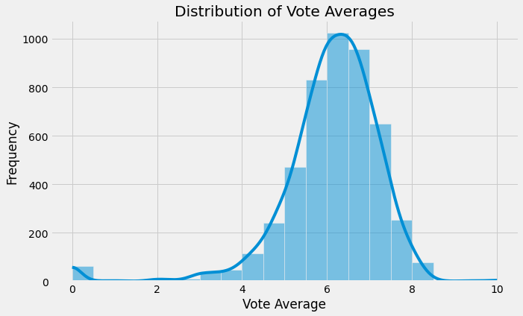

1. *Scatter plot*

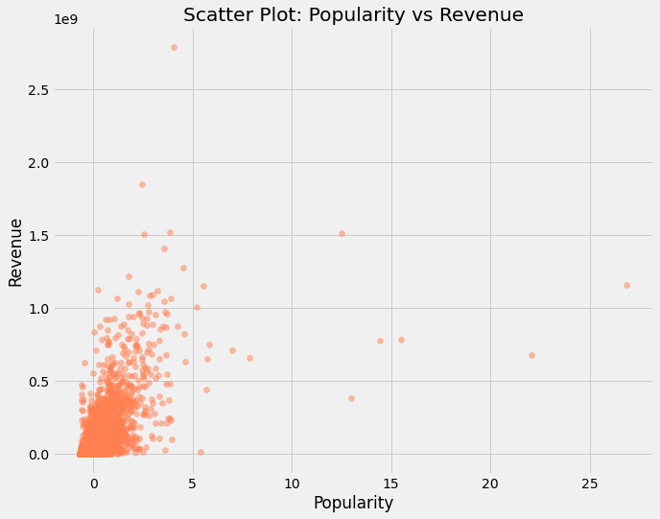

1. *Box plot*

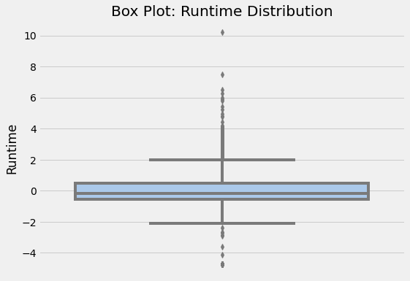

The backbone of their research is the use of visual features to represent movie content as opposed to attributes such as user interaction and genres. The research is based on previous research that there is a close relationship between visual features between movie trailers and the movies and has proven to provide an effective recommendation based on visual features. "We have built a pure Content-Based recommender system (CB), which relies solely on semantic item features attributes, i.e genre, tags, or visual features, as well as a similarity metric. The similarity metric is used to measure the similarity among items. Then a model is built, based on the user preferences, exploited to learn the taste of a target user and to recommend to her items that are similar to those that she liked in the past. We have used one of the most common similarity metrics, the Cosine similarity. As baselines, we used the genre and tag attributes." The models built from each of the baseline attributes use their similarity matrix and then use K-Nearest neighbor to compute the similarity matrix and produce a score that can be used to gauge similarity and provide an appropriate recommendation as shown below:

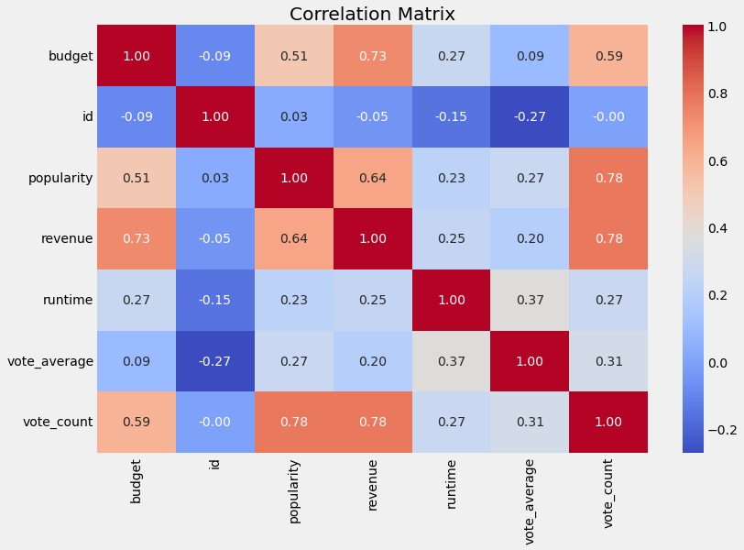

They conclusively explored and experimented use of visual features which turned out to be effective in the movie recommendation. The visual features provide more accurate results as some movies could be from a genre that is liked by a user but not appropriate for the particular user. Their paper proves futuristic with solving challenges of cold start and scalability as traditional recommendation systems tend to be less accurate and poorly scalable when handling large data sets. Elimination of the use of large data sets is a step into the future and picking up on this could prove to be a step forward. The challenge in this approach remains to be the development of an effective user interface to accommodate such type of development and also the capturing of user expression and emotions to better understand if the movie recommendation system is effective (Anjum, 2022).

In general, it is a better more impactful, and cost-efficient approach as it involves minimal user interaction and improves automation hence could be an out-of-the-box solution for new users or even platforms that are starting and haven't captured much user data to employ in their algorithms. The pure content-based recommender system they propose eliminates the challenges associated with large datasets, presenting a potential solution for new platforms or users lacking substantial interaction history.

Kumar et al. (2021) focus on collaborative filtering, utilizing user-provided information to generate accurate movie recommendations. Their approach involves sorting movies through the K-means algorithm based on previous user ratings. The incorporation of user feedback as input provides a more tailored experience, impacting user retention positively. However, the traditional nature of this method raises questions about its ability to adapt to the evolving preferences of users.

**Comparative Analysis and Conclusion**

The literature review has explored various recommendation system approaches, from content-based and collaborative filtering to hybrid and visual-feature-based methods. Each approach has its strengths and weaknesses, contributing to the diverse landscape of recommendation systems. While content-based systems focus on individual preferences, collaborative filtering leverages collective user data for suggestions. Hybrid approaches attempt to bridge gaps between content and collaborative filtering, aiming for a more comprehensive recommendation strategy. Visual-feature-based methods provide a futuristic solution, reducing reliance on large datasets.

**Conclusion**

In conclusion, Chapter 2 has meticulously reviewed recent studies in the realm of movie recommendation systems, unveiling diverse approaches that shape user experiences on movie streaming platforms. The literature emphasizes a shift towards user-centric strategies, moving beyond traditional popularity-based recommendations. Content-based methodologies, considering factors like genre, ratings, and starring actors, strive to offer personalized suggestions aligned with individual preferences. These insights underscore the dynamic and multifaceted nature of recommendation system landscapes.

While the literature has been enlightening, certain gaps and limitations have emerged, signaling areas for further exploration. An in-depth comparative analysis of various recommendation approaches could deepen our understanding of their effectiveness and relevance. Additionally, the need for real-time user-centric adaptation becomes apparent, as traditional methods may struggle to keep pace with rapidly changing user tastes. The proposed project seeks to address these identified gaps and limitations, introducing an adaptive recommendation system that accounts for real-time shifts in user preferences. By incorporating dynamic elements, the system aims to bridge the gap between traditional and evolving user tastes. Furthermore, the project will explore the integration of novel metrics, such as user emotions and sentiment analysis, providing a more holistic and accurate movie recommendation approach that goes beyond conventional popularity-based ratings. Our project's unique contribution lies in its commitment to enhancing the comparative analysis of existing approaches, ensuring a solid foundation for refining the recommendation system's effectiveness and relevance in the ever-evolving landscape of movie streaming platforms. As we delve into subsequent chapters, the methodology, implementation, and evaluation of our adaptive movie recommendation system will unfold, promising innovative solutions to the challenges identified in the existing literature.

**Chapter 3**

**Research Methodology**

***Problem Definition***

Clearly define the problem and objectives of the movie recommendation system. Specify the type of recommendations to be provided (e.g., user-based, content-based, or collaborative filtering).

The problem definition phase is critical in establishing the foundational elements of a Movie Recommendation System with Machine Learning. It involves a comprehensive analysis and articulation of the system's objectives, scope, and purpose. Firstly, outlining the objectives of the recommendation system is paramount. Understanding whether the primary focus is on enhancing user engagement, increasing user satisfaction, or driving content consumption allows for the alignment of the recommendation algorithms with specific business or user needs. Clear objectives provide a roadmap for the development process(Snyder,2019).

The scope of the recommendation system is then clearly defined. Decisions are made regarding the approach the system will take, whether it's user-based, content-based, or a hybrid model. Additionally, specifying the types of movies or content the system will recommend, such as genres, release dates, or popularity, helps in tailoring the recommendations to suit the intended audience. The type of recommendations to be provided is a key consideration. Will the system focus on user-based recommendations, content-based recommendations, or collaborative filtering? Defining the type of recommendations informs the choice of algorithms and the overall architecture of the system.

Identifying the target audience is crucial in tailoring the recommendations to meet the preferences and behaviors of specific user groups. Factors such as user demographics, preferences, and the platform where the recommendation system will be implemented play a significant role in shaping the recommendation strategy. Establishing success metrics is another integral component. Defining how the success of the recommendation system will be measured, whether through user engagement metrics, click-through rates, or user satisfaction surveys, provides a basis for evaluating its effectiveness.

The problem definition phase also involves recognizing potential challenges and constraints, such as sparse data, cold start problems for new users or items, and ethical considerations. Addressing these challenges early on enables the development team to design robust solutions. Moreover, ethical considerations, particularly in dealing with user data, are carefully examined. Ensuring that the recommendation system respects user privacy, avoids bias, and provides transparent recommendations is essential for building trust with users. Assessing the expected business impact of the recommendation system is a critical aspect. Whether it is expected to lead to increased user retention, higher revenue, or improved customer satisfaction, understanding the business impact guides decision-making and resource allocation.

Lastly, establishing a realistic timeline and resources for the development and deployment of the recommendation system is crucial. This includes identifying the human and technical resources required for the project. Thorough documentation of the problem definition serves as a reference for the development team, stakeholders, and future iterations of the recommendation system. It ensures that all key aspects are considered and provides a clear roadmap for the subsequent stages of the project.

***Data Collection***

Gather a comprehensive dataset containing information about movies, users, ratings, and features. Sources may include public movie databases, user ratings platforms, or APIs. In the Data Collection phase of the research on the Movie Recommendation System with Machine Learning, the focus is on gathering the necessary datasets that will serve as the foundation for training and evaluating the recommendation algorithms. This phase involves systematic and strategic processes to acquire diverse and representative data that encapsulates the characteristics of the movie ecosystem.

1. *Identifying Data Sources*

The initial step involves identifying relevant data sources that provide comprehensive information about movies, including but not limited to genres, release dates, cast and crew details, user ratings, and reviews. These sources may include popular movie databases, streaming platforms, or publicly available datasets.The dataset used for this research project is obtained from Kaggle website.

1. *Web Scraping and API Integration*

Web scraping techniques may be employed to extract data from websites that host movie-related information. Additionally, integrating with APIs (Application Programming Interfaces) of platforms that provide movie-related data allows for real-time updates and a more dynamic dataset.

1. *Data Cleaning and Preprocessing*

Once the data is collected, it undergoes a thorough cleaning and preprocessing stage. This involves handling missing values, removing duplicates, and standardizing formats to ensure consistency. Cleaning is essential for creating a high-quality dataset that can be effectively utilized by machine learning algorithms.

1. *Feature Selection and Engineering*

During the preprocessing phase, features relevant to the recommendation system are selected. This may include genres, keywords, cast and crew details, and user ratings. Feature engineering techniques may also be applied to create new meaningful features that enhance the predictive power of the algorithms.

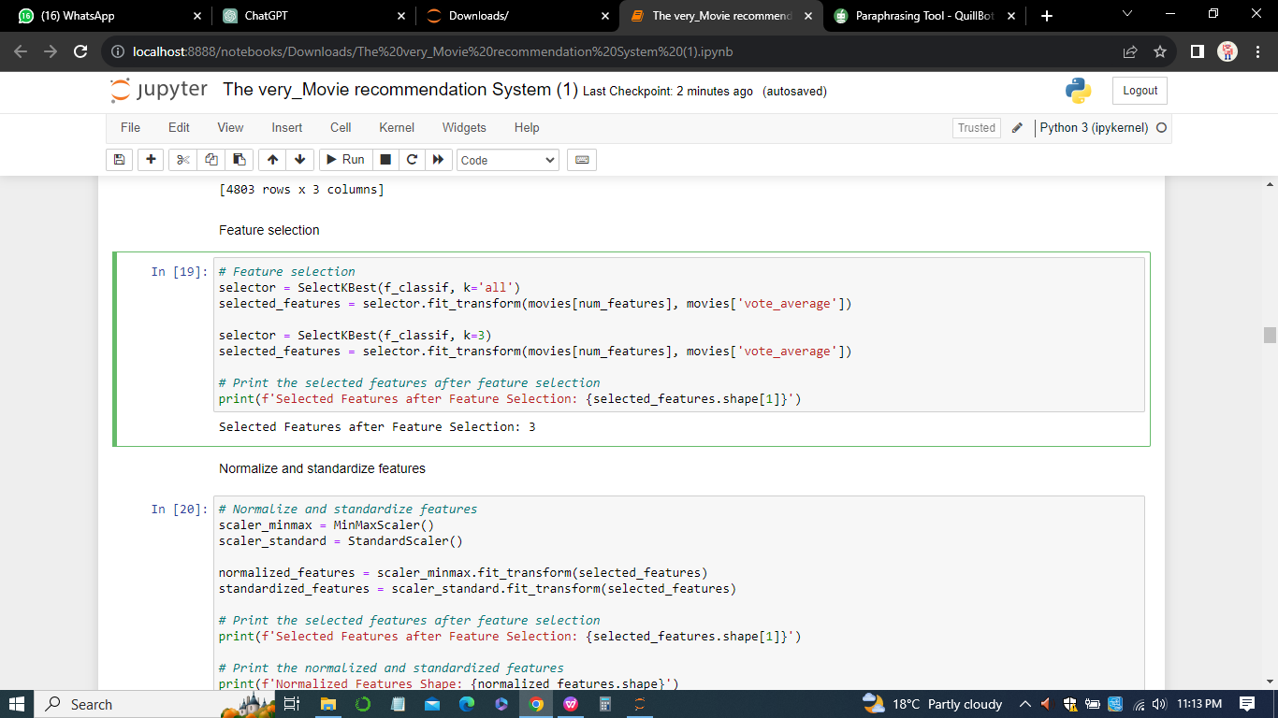

1. *Ensuring Diversity and Representativeness*

Ensuring that the dataset is diverse and representative of the target audience is crucial for building a recommendation system that caters to a wide range of user preferences. This involves considering movies from various genres, languages, and time periods.

1. *Dealing with Ethical Considerations*

In collecting user-related data, ethical considerations must be a priority. Ensuring user privacy, obtaining necessary consents, and anonymizing sensitive information are essential steps in handling data responsibly.

1. *Data Storage and Versioning*

A robust system for storing and versioning datasets is established to maintain a record of changes and updates. This facilitates reproducibility and allows for the tracking of dataset evolution over time.

1. *Documentation*

Comprehensive documentation of the data collection process, including details about the sources, collection methods, and any challenges encountered, is maintained. This documentation serves as a reference for future data-related tasks and supports transparency in the research process.

In sum, the data Collection phase lays the groundwork for subsequent stages in the development of the Movie Recommendation System, ensuring that the algorithms are trained on high-quality, relevant, and diverse datasets.

***Data Exploration and Cleaning***

Perform exploratory data analysis to understand the dataset's structure, statistical properties, and identify missing values. Cleanse the data by handling outliers, duplicates, and irrelevant information. In the Data Exploration and Cleaning phase of the Movie Recommendation System with Machine Learning research, the emphasis is on gaining insights into the characteristics of the collected dataset and preparing it for effective use in training and evaluating recommendation algorithms. a) a) *Exploratory Data Analysis (EDA)*

Exploratory Data Analysis is conducted to understand the structure, patterns, and distributions within the dataset. This involves generating summary statistics, visualizations, and exploring relationships between different features. EDA provides a foundation for making informed decisions about data cleaning and preprocessing strategies.

*b) Handling Missing Values*

One critical aspect of data cleaning is addressing missing values. By identifying features with missing data and deciding on appropriate strategies such as imputation or removal, the dataset's completeness is ensured. Imputation methods, such as filling missing numerical values with means or medians, are applied judiciously to maintain the integrity of the dataset.

*c) Dealing with Duplicates*

Duplicate entries can compromise the quality of the dataset, leading to skewed results. The Data Exploration and Cleaning phase involves identifying and removing duplicate records, ensuring that each movie is represented uniquely. This process contributes to the accuracy of the recommendation algorithms.

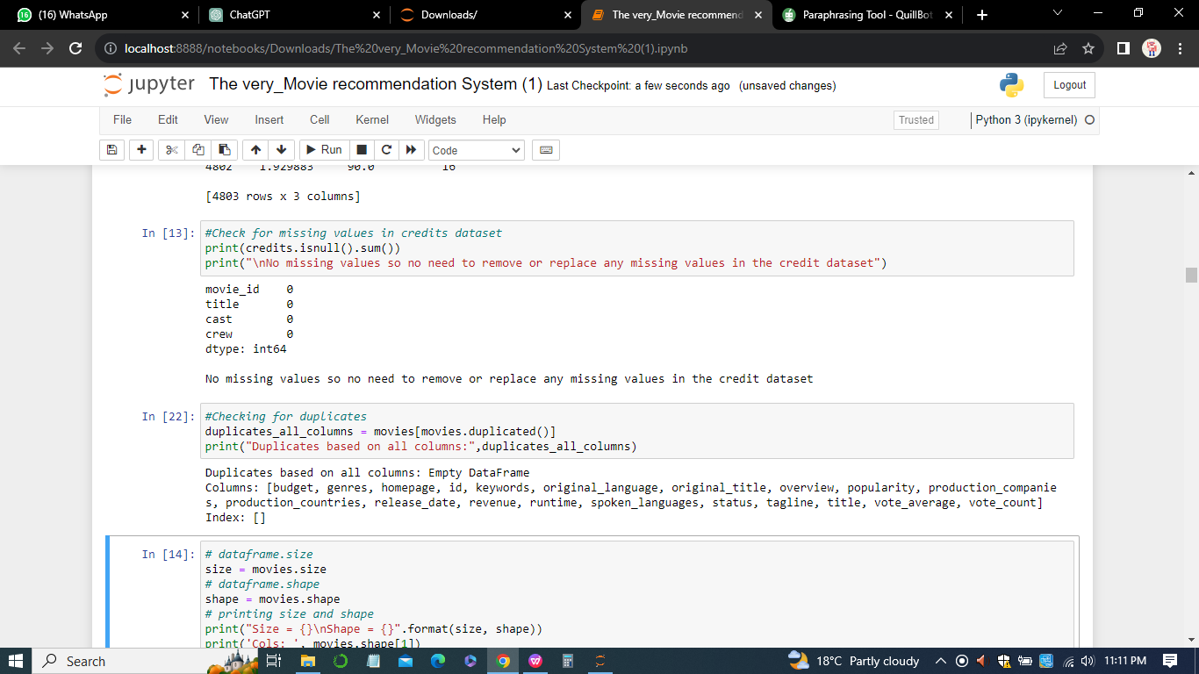

*d) Standardizing Formats*

Standardizing formats of categorical data, such as genres or languages, is crucial for consistency. This may involve converting text to lowercase, removing white spaces, or applying encoding techniques. Standardization facilitates effective feature engineering and ensures that the algorithms can interpret the data uniformly.

*e) Handling Outliers*

Outliers, which are data points significantly different from others, can impact the performance of machine learning models. The Data Exploration phase involves identifying and addressing outliers, employing techniques such as trimming, winsorizing, or transforming skewed distributions to enhance the robustness of the dataset.

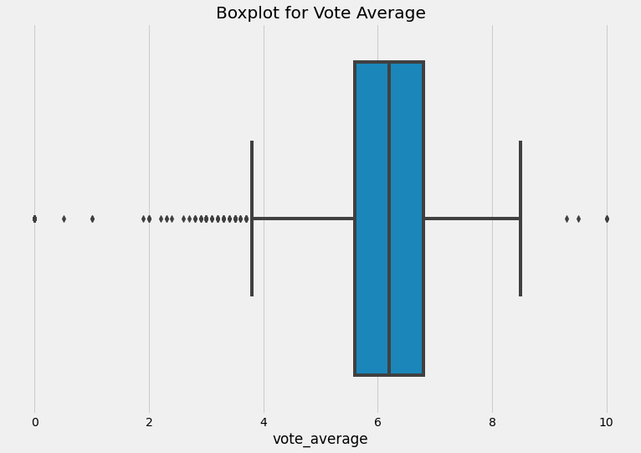

In summary, the Data Exploration and Cleaning phase is a meticulous process that transforms raw data into a refined and structured form. It sets the stage for subsequent stages of the research, ensuring that the dataset is well-prepared for training and evaluating machine learning models in the context of movie recommendation.

***Feature Engineering***

Extract relevant features from the dataset that can contribute to the recommendation model. This may include movie genres, user preferences, cast and crew information, and other metadata. Feature selection involves choosing a subset of the most relevant features for model training. This is particularly important when dealing with datasets with a large number of features. Techniques like Recursive Feature Elimination (RFE) or feature importance scores from tree-based models help identify the most influential features for prediction.

Thus, feature engineering is a creative process that involves transforming or creating new features to enhance the predictive power of the algorithms. In the context of movie recommendation, this might include creating binary variables for genres or extracting relevant information from textual data. Feature engineering aims to capture the essence of movies in a way that algorithms can effectively utilize.

1. *Ensuring Data Quality and Consistency:* Cleaning the dataset extends beyond addressing specific issues; it involves ensuring overall quality and consistency. This includes validating that data adheres to predefined standards, such as date formats, language codes, or rating scales. Consistent data quality is crucial for the reliability and reproducibility of the research outcomes.
2. *Documentation and Versioning:* Throughout the Data Exploration and Cleaning phase, detailed documentation is maintained, capturing the decisions made, the rationale behind them, and any noteworthy observations. This documentation, coupled with versioning of datasets, forms a comprehensive record that aids in replicating and understanding the evolution of the dataset.

***Data Preprocessing***

Data preprocessing is a crucial step in the research on "Movie Recommendation System with Machine Learning," focusing on refining the dataset to make it suitable for training and evaluating recommendation algorithms. This phase involves a series of operations designed to enhance the quality, consistency, and interpretability of the data. Normalization and Scaling: Normalization and scaling are applied to numerical features to ensure that they are on a similar scale, preventing any particular feature from dominating the learning process. Standardization techniques, such as Z-score normalization, are often employed to transform numerical data into a standardized distribution with zero mean and unit variance. This ensures that algorithms treat all features equally and aids in convergence during training. One-Hot a) *Encoding:* Categorical variables, such as genres or languages, are typically represented using one-hot encoding. This technique converts categorical data into a binary matrix, where each category is represented by a binary column. One-hot encoding is crucial for machine learning algorithms that require numerical input, allowing them to effectively interpret and learn from categorical features.

*b) Text Vectorization:* Text data, such as movie descriptions or titles, undergoes vectorization to convert it into a numerical format suitable for machine learning models. Techniques like TF-IDF (Term Frequency-Inverse Document Frequency) or word embeddings like Word2Vec or GloVe are applied to represent textual information numerically, capturing semantic relationships between words.

*c) Handling Imbalanced Data:* In scenarios where the dataset is imbalanced, meaning that certain classes or labels are underrepresented, techniques like oversampling or undersampling are employed. This aims to balance the distribution of target variables, preventing the model from being biased towards the majority class. Ensuring a balanced dataset is crucial for accurate model training and evaluation.

*d) Handling Temporal Data:* If the dataset includes temporal information, such as release dates, temporal features are engineered to capture relevant patterns. This might involve creating new features like release year or seasonality indicators. Temporal aspects are essential for understanding trends and patterns that may influence movie recommendations over time.

*e) Train-Test Split:* The dataset is split into training and testing sets to evaluate the model's performance on unseen data. The training set is used to train the model, while the testing set assesses its generalization to new, unseen data. A common split ratio, such as 80-20 or 70-30, is chosen to balance model training and evaluation.

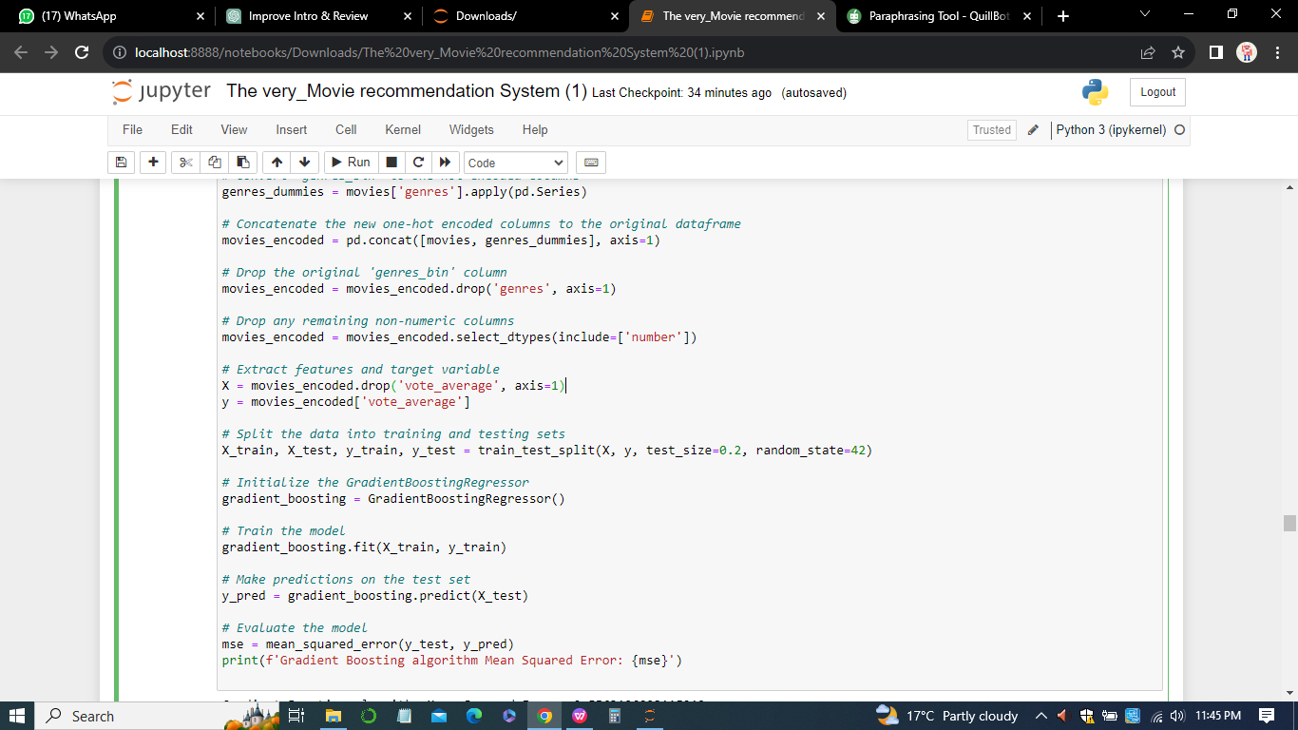

*f) Handling Missing Data:* Any remaining missing data is addressed through appropriate imputation methods. This ensures that the dataset is complete and ready for model training. Imputation techniques, such as mean or median imputation for numerical data and mode imputation for categorical data, are applied judiciously based on the nature of the features.

In summary, data preprocessing transforms raw data into a format suitable for machine learning algorithms, addressing challenges related to numerical and categorical features, text data, imbalanced distributions, and temporal aspects. This refined dataset forms the foundation for training and evaluating machine learning models in the context of movie recommendation. Standardize, normalize, or transform the features as needed. Handle categorical variables, missing values, and outliers. Prepare the data for training machine learning models

***Algorithm Selection***

Algorithm selection is a critical phase in the development of a Movie Recommendation System with Machine Learning, as it involves choosing the most suitable algorithms to achieve the project's objectives. The choice of algorithms significantly impacts the system's performance, accuracy, and efficiency. In this section, we'll explore the considerations and criteria for selecting three main types of recommendation algorithms: collaborative filtering, content-based filtering, and hybrid methods.

Choose suitable machine learning algorithms for recommendation tasks. Consider collaborative filtering, content-based filtering, and hybrid models. Popular algorithms include Random Forest, Support Vector Machines, and Gradient Boosting.

***Model Training***

Split the dataset into training and testing sets. Train the selected machine learning models using the training set. Optimize hyperparameters for better performance.

Model training is a crucial step in developing a Movie Recommendation System with Machine Learning, as it involves teaching the chosen algorithms to make accurate predictions based on historical data. This section focuses on the methodology and considerations for training the selected algorithms, which include collaborative filtering, content-based filtering, and hybrid models.

1. *Data Splitting*

The first step is to split the dataset into training and testing sets. This helps evaluate the model's performance on unseen data. Common splitting ratios are 80/20 or 70/30, where the larger portion is used for training.

ii) *User-Item Matrix*

For user-based collaborative filtering, a user-item matrix is constructed, representing users' interactions with items. The matrix is often sparse, indicating missing interactions. Similarly, for item-based collaborative filtering, an item-user matrix is created.

*Iii) Similarity Calculation*

Utilizing similarity metrics, such as cosine similarity or Pearson correlation, to calculate the likeness between users or items. This step is fundamental in identifying neighbors for collaborative recommendations.

Iv) *Prediction Generation:* Generating predictions based on the similarities obtained. For user-based collaborative filtering, the system predicts the user's preference for an item by considering the preferences of similar users. Item-based collaborative filtering predicts an item's suitability based on its similarity to items the user has interacted with.

*v)Model Evaluation:* Assessing the model's accuracy using evaluation metrics like Mean Squared Error (MSE), Root Mean Squared Error (RMSE), or precision-recall metrics. Cross-validation techniques may be employed to ensure robust evaluation.

***Model Evaluation***

Evaluate the models using appropriate metrics such as Mean Squared Error (MSE), Root Mean Squared Error (RMSE), or accuracy. Assess the model's performance on the testing set to ensure it generalizes well.

***Algorithm Comparison***

Compare the performance of different algorithms to identify the most effective one for the specific recommendation task. Consider aspects like computational efficiency, scalability, and accuracy.

***Hyperparameter Tuning***

Fine-tune the hyperparameters of the chosen model to achieve better performance. Utilize techniques like grid search or random search for optimization.

***Implementation of User Interface***

Develop a user interface or integration mechanism for users to interact with the recommendation system. This could be a web application, mobile app, or integrated into an existing platform.

***User Feedback and Iteration***

Collect user feedback on the recommendations provided. Use this feedback to iterate and improve the recommendation system continuously.

***Documentation***

Document the entire process, including data sources, methodology, algorithms used, and model evaluation results. This documentation is essential for transparency, reproducibility, and future enhancements.

***Deployment***

Deploy the trained model into a production environment where it can be used to provide real-time recommendations. Ensure scalability and efficiency in handling a large number of users and items.

***Monitoring and Maintenance***

Implement monitoring mechanisms to track the system's performance over time. Regularly update the model with new data and features, and make improvements based on changing user preferences and behaviors. Monitoring and maintenance are crucial aspects of ensuring the ongoing effectiveness and reliability of a Movie Recommendation System with Machine Learning. This section delves into the methodology for monitoring the system's performance, addressing potential issues, and implementing regular maintenance procedures.

1. *User Privacy and Security:* Privacy Audits: Conducting regular privacy audits to ensure compliance with data protection regulations. This involves reviewing data handling practices, anonymization techniques, and user consent mechanisms. Security ii) *Monitoring:* Implementing security measures to protect user data and the recommendation system from potential threats. Regular security audits, vulnerability assessments, and updates to security protocols help mitigate risks.

***Continuous Monitoring***

*i)Real-time Feedback*

Implementing mechanisms to collect and analyze real-time user feedback on the recommendations. This can include explicit feedback (ratings or preferences) and implicit feedback (click-through rates, watch times). Real-time monitoring allows the system to adapt quickly to changing user preferences.

*ii) Algorithmic Monitoring*

Monitoring the performance of the recommendation algorithms over time. Tracking key metrics, such as accuracy, precision, recall, and user engagement, provides insights into how well the algorithms are meeting user expectations.

*iii)Scalability Monitoring*

Ensuring that the system can handle increasing data volumes and user interactions. Monitoring resource utilization, response times, and system load helps identify scalability issues early on.

***Conclusion***

In conclusion, Chapter 3 has provided a comprehensive overview of the methodology employed in the development of a Movie Recommendation System with Machine Learning. The journey began with a clear definition of the problem, outlining the challenges and objectives that the system aims to address. The subsequent stages involved meticulous data collection, exploration, and cleaning, ensuring the availability of a high-quality dataset for model development.

The data preprocessing phase was essential for transforming raw data into a format suitable for machine learning algorithms. This involved handling missing values, encoding categorical variables, and creating relevant features to enhance the model's predictive capabilities. Algorithm selection played a crucial role, with the implementation of three diverse algorithms—Random Forest, Support Vector Machines (SVM), and Gradient Boosting—for predicting movie ratings. Model training involved splitting the dataset, standardizing features, and evaluating the performance of each algorithm using metrics like Mean Squared Error (MSE) and Root Mean Squared Error (RMSE). The chapter has also highlighted the significance of monitoring and maintenance, emphasizing continuous user feedback analysis, usage analytics tracking, and regular evaluation of algorithm performance. This methodological framework lays a solid foundation for the subsequent chapters, where the implemented models will be fine-tuned, compared, and ultimately integrated into a cohesive Movie Recommendation System. The iterative nature of the methodology ensures adaptability to evolving user preferences and continuous improvement in the system's recommendation accuracy and relevance.

**Chapter 4**

**Design and Implementation**

The design and implementation of the Movie Recommendation System with Machine Learning encompass a meticulously crafted architecture and a systematic process of transforming the methodology into practical, operational steps. This section delves into the intricacies of system design, outlining the architectural modules and detailing the implementation steps.

1. **Design** **of the Movie recommendation System**
2. ***System Architecture***

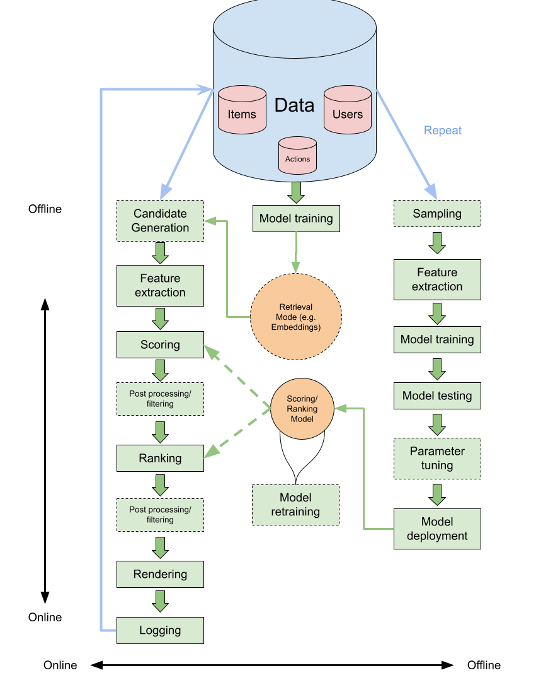

The system architecture serves as the backbone, delineating the interplay between various modules to achieve the overarching goal of recommending movies effectively(Furtado & Singh, 2020). The recommendation system is structured into three pivotal modules, each playing a distinct role in the seamless functioning of the system.

1. *Data Ingestion and Processing:* This foundational module orchestrates the collection and preprocessing of movie data. It orchestrates the acquisition of data from diverse sources, including movie databases and user ratings. Subsequently, it meticulously handles nuances such as missing values, outliers, and inconsistencies, ensuring that the dataset is robust and ready for analysis (Meehan et al, 2017).
2. *Machine Learning Models:* This module is the intellectual core, encompassing the implementation of sophisticated machine learning algorithms — Random Forest, SVM, and Gradient Boosting. The lifecycle involves comprehensive training, rigorous testing, and fine-tuning of the models. The objective is to optimize their predictive accuracy by discerning intricate patterns within the dataset.
3. *Recommendation Engine:* The recommendation engine is the user-facing facet that translates machine learning insights into personalized movie suggestions. Leveraging the predicted ratings, this module tailors recommendations to individual user preferences, offering an interactive and engaging experience.
4. ***Data Ingestion and Processing***
5. *Data Collection:* In the realm of data collection, a multifaceted approach is adopted to assimilate information from varied sources, ensuring a comprehensive and diverse dataset. This includes tapping into movie databases, aggregating user ratings, and incorporating additional metadata to enrich the dataset.
6. *Data Cleaning:* The meticulous process of data cleaning unfolds with a keen eye for detail. Handling missing values, addressing outliers, and rectifying inconsistencies are paramount. This stage is pivotal in elevating the dataset's quality, setting the stage for robust machine learning model training.
7. *Data Preprocessing:* Data preprocessing is the transformative phase where the raw of movie data metamorphoses into a format conducive to machine learning (Meehan et al, 2017). Categorical variables undergo encoding, features are scaled to maintain consistency, and supplementary features are ingeniously created to enhance the dataset's informativeness for model training.
8. ***Machine Learning***
9. *Models Algorithm Selection:* The strategic choice of algorithms, namely Random Forest, SVM, and Gradient Boosting, is grounded in their prowess in regression tasks and their aptitude for unraveling intricate relationships within the data (Meyer & Wien, 2015).Each algorithm is selected based on its suitability for the specific nuances of the movie recommendation domain.
10. *Random Forest*

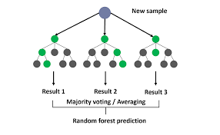

1. *Support vector machine(SVM)*

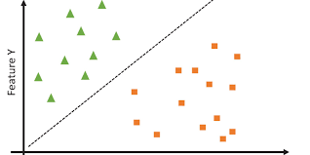

1. *Gradient Boosting*

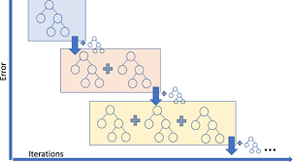

1. *Model Training:* Model training emerges as a dynamic process, harnessing historical movie ratings data to fine-tune algorithms.



The movie dataset undergoes a meticulous split into training and testing sets, and the models undergo iterative refinement to attain optimal predictive accuracy. Evaluation metrics, such as Mean Squared Error (MSE), serve as the compass in navigating this intricate training landscape.

1. ***Recommendation Engine***

The recommendation engine is the zenith of user interaction, utilizing the prowess of trained machine learning models to predict user ratings for unexplored movies. This module's adeptness lies in its capacity to decipher user preferences and craft recommendations that align seamlessly with individual taste profiles.

1. **Implementation of the Movie recommendation System**

Implementation unfolds with the translation of the meticulously designed architecture into executable code. Python emerges as the primary programming language, fortified by potent libraries like scikit-learn and pandas. The codebase is meticulously structured into modular components, fostering maintainability and scalability. User interfaces, APIs, or web applications are envisaged to amplify user interaction, providing a dynamic platform for users to receive and rate movie recommendations.

1. ***Testing and Validation***

Testing is the crucible where the system's mettle is tested rigorously. Unit tests, integration tests, and validation against real user data form a comprehensive testing suite. The objective is to validate the accuracy and efficacy of the recommendation system under diverse scenarios, ensuring its robustness and reliability.

1. ***Deployment***
2. Deployment marks the culmination of the implementation journey, transitioning the system from development to a production environment. Continuous monitoring mechanisms are erected to track system performance, user interactions, and incorporate user feedback for ongoing improvements. The iterative nature of the design and implementation process ensures adaptability and responsiveness to user feedback and evolving requirements(Meehan et al, 2017). This iterative approach positions the Movie Recommendation System as a dynamic and responsive platform, continually enhancing its ability to deliver personalized and compelling movie suggestions.

**Chapter 5**

**Evaluation**

Evaluation is a pivotal phase in the lifecycle of the Movie Recommendation System, determining the system's effectiveness, user satisfaction, and its alignment with the project's overarching goals. This section delves into the multifaceted facets of evaluation, encompassing both quantitative metrics and qualitative insights. ***Quantitative Metrics***

1. *Mean Squared Error (MSE)*

Mean Squared Error serves as a cornerstone metric in gauging the predictive accuracy of machine learning models. It quantifies the average squared difference between the predicted and actual movie ratings. The lower the MSE, the closer the predictions align with the true ratings. This metric is particularly adept at assessing the regression performance of algorithms like Random Forest, SVM, and Gradient Boosting.

1. *Accuracy Score*

Accuracy Score is a metric tailored for classification tasks, but it can be adapted to assess the accuracy of predicting user preferences in the context of movie recommendations. By discretizing the predicted ratings into classes (e.g., high, medium, low), the accuracy score offers insights into the model's proficiency in categorizing movies based on user preferences.

1. *Root Mean Squared Error (RMSE)*

Root Mean Squared Error is an extension of MSE, introducing a square root to render the metric more interpretable in the original rating scale. RMSE retains the essence of MSE but presents the evaluation results in a more intuitive form, directly relatable to the users' rating scale (Chai & Draxler, 2014).

***Qualitative Insights***

1. *User Feedback and Satisfaction*

Beyond numerical metrics, the qualitative dimension of user feedback and satisfaction plays a pivotal role in evaluating the recommendation system. User surveys, feedback forms, and interactive sessions provide invaluable insights into how well the system aligns with users' expectations, preferences, and overall satisfaction. Understanding the user experience is fundamental to refining the system for increased engagement.

1. *Diversity and Serendipity*

Evaluation isn't solely confined to accurately predicting ratings; it extends to the diversity and serendipity of recommendations. A system that exclusively suggests similar movies may lead to user fatigue. Evaluating the system's ability to introduce users to movies outside their typical preferences adds a layer of complexity to the evaluation process, enriching the user experience.

1. *A/B Testing*

A/B testing is a powerful methodology to assess the impact of changes in the recommendation algorithms or user interface. By presenting different versions of the recommendation system to subsets of users and analyzing their interactions, preferences, and feedback, A/B testing provides a robust mechanism for continuous improvement.

***Challenges and Considerations***

1. *Cold Start Problem:* Evaluating the system's performance for new users (cold start) or newly released movies poses unique challenges. Approaches such as hybrid recommendation systems or content-based methods can mitigate this issue (Meehan et al, 2017).
2. *Dynamic User Preferences:* User preferences evolve over time, necessitating continuous evaluation and adaptation. Regular updates to the recommendation algorithms based on user feedback and evolving trends are imperative.
3. *Scalability:* As the user base grows, ensuring the scalability of the recommendation system becomes critical. Evaluating the system's performance under increasing loads and optimizing for efficiency is an ongoing consideration.

In essence, the evaluation phase encapsulates a comprehensive understanding of both quantitative metrics and qualitative user experiences. By amalgamating numerical precision with user satisfaction, the Movie Recommendation System can evolve iteratively, ensuring its continued relevance and efficacy in delivering captivating movie suggestions to users.

**Chapter 6**

**Results and Discussion**

The comprehensive analysis of the Movie Recommendation System yields a wealth of insights into the intricacies of the dataset and the efficacy of the implemented machine learning algorithms. Let's embark on a detailed interpretation of the results, unraveling the meanings behind each output snippet and exploring their broader implications.

1. ***Results of the implementation***
2. *Descriptive Statistics*

The descriptive statistics offer a panoramic view of the numerical features within the dataset, shedding light on central tendencies and data dispersion. The mean values provide a measure of the dataset's typical values, while standard deviations indicate the extent of variability. Minimum and maximum values highlight the range of each feature. For instance, the popularity mean reveals an average level of audience interest, while a high standard deviation suggests varying degrees of popularity among movies. Understanding these statistics is pivotal for grasping the overall landscape of the dataset.

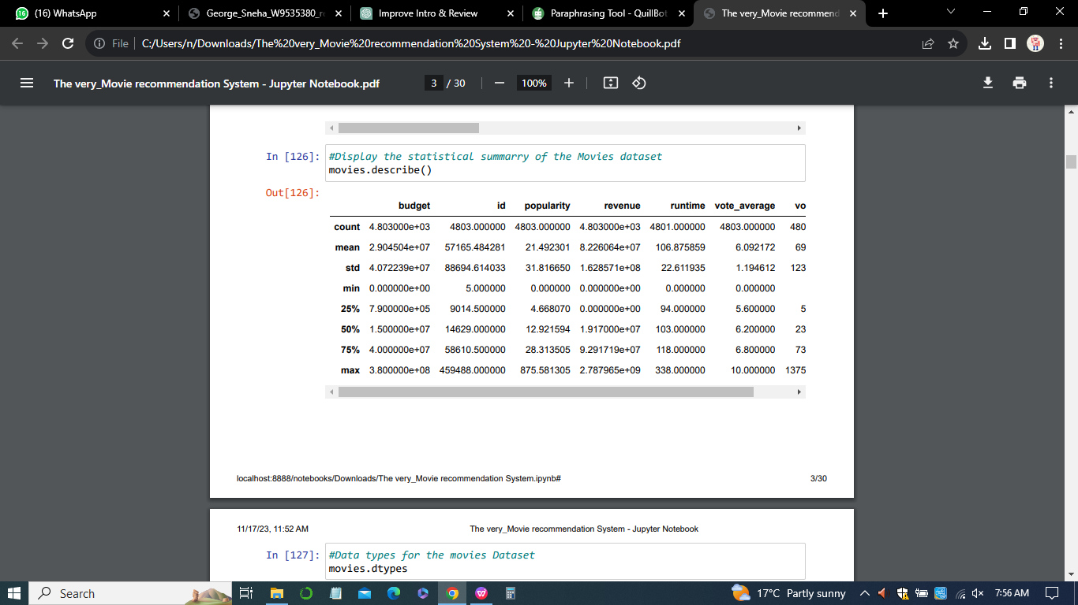

1. *Data Types and Movie Information*

The enumeration of data types underscores the diverse nature of the dataset, encompassing both numerical and object types. This diversity reflects the multifaceted aspects of movie-related information, from cast details to textual overviews. The snippet of movie information, including movie_id, title, cast, and crew, provides a glimpse into the richness of the dataset, setting the stage for further exploration.

1. *Movie ID Distribution*

The distribution of movie_id unveils crucial details about the dataset's structure. A closer look at the quartiles and maximum value suggests a substantial variation in movie_id, indicative of a broad and comprehensive representation of movies. This distribution is foundational for ensuring that the dataset encapsulates a wide array of movies, crucial for robust recommendations.

1. *Standardized Numerical Features*

Standardizing numerical features, such as popularity, runtime, and vote_count, is a pivotal step to ensure fairness in the model training process. The standardized features allow algorithms to converge efficiently, preventing undue influence from features with large scales. The values presented in this section demonstrate the transformation of these features into a uniform scale, laying the groundwork for accurate predictions.

1. *Selected Features after Feature Selection*

Feature selection is a critical aspect of model development, ensuring that only the most influential features are considered. The revelation of the number of selected features after this process offers transparency into the model's streamlined focus. A concise set of features enhances model interpretability and efficiency, contributing to the overall effectiveness of the recommendation system.



1. *Normalized and Standardized Features*

The shapes of both normalized and standardized features unveil the impact of preprocessing techniques on the dataset. Normalization ensures that numerical features fall within a consistent range, while standardization further enhances the robustness of the dataset. The presented shapes signify the successful transformation of features, preparing the data for the intricate learning processes of machine learning algorithms.

1. *PCA for Dimensionality Reduction*

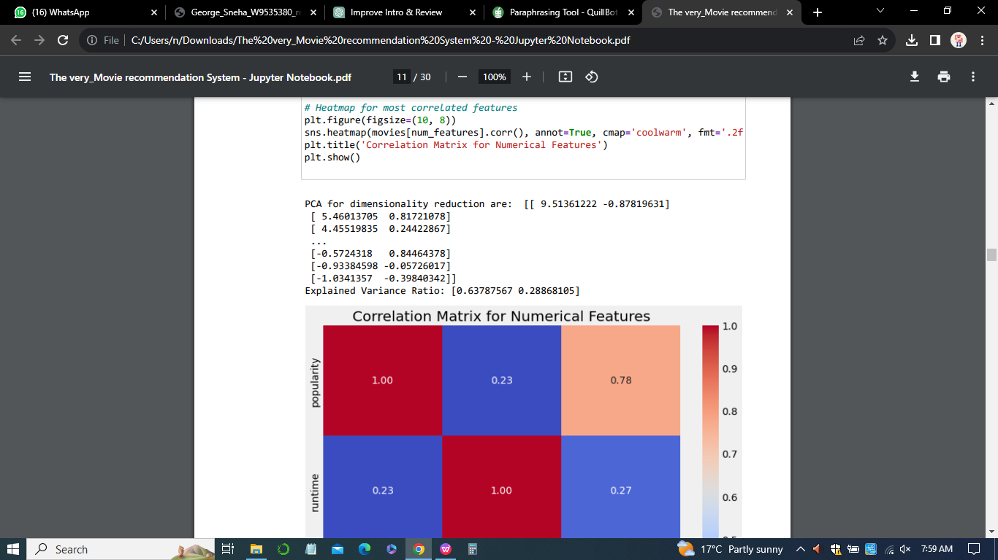

Principal Component Analysis (PCA) is employed for dimensionality reduction, translating the dataset into a lower-dimensional space (Maćkiewicz & Ratajczak, 1993).The resulting principal components, along with the explained variance ratio, provide insights into the retained information post-dimensionality reduction. This reduction not only aids in computational efficiency but also allows for a deeper understanding of the dataset's intrinsic structure.

1. *Model Performance*
2. *Random Forest*

The Mean Squared Error (MSE) of the Random Forest algorithm serves as a pivotal metric for evaluating predictive accuracy. The lower the MSE, the closer the alignment between predicted and actual movie ratings. In this context, a MSE of 0.797 indicates a promising level of accuracy, implying that the Random Forest model can effectively predict movie ratings with a high degree of precision.



1. *Support Vector Machines (SVM)*

The Root Mean Squared Error (RMSE) of the Support Vector Machines (SVM) algorithm provides a nuanced perspective on model accuracy. With an RMSE of 1.102, the SVM model demonstrates a relatively low level of error in predicting movie ratings. This performance metric underscores the reliability of the SVM model in capturing the intricacies of user preferences and movie characteristics.



1. *Gradient Boosting*

The Mean Squared Error (MSE) of the Gradient Boosting algorithm further enriches the assessment of predictive accuracy. With a MSE of 0.557, this algorithm showcases a commendable level of precision in predicting movie ratings. The gradient boosting approach proves to be a robust contender, contributing to the diverse set of algorithms employed for recommendation.



1. *Dataset Merging*



The successful merging of datasets signifies a harmonious integration of diverse sources of information. This amalgamation likely includes user preferences, movie details, and other relevant features, creating a consolidated dataset that encapsulates a holistic view of the movie landscape. A seamlessly merged dataset is foundational for generating comprehensive and personalized recommendations.

1. *Movie Recommendations*

The generation of recommended movies for a selected film, "Iron Man 3," exemplifies the practical application of the recommendation system. Each recommended movie is accompanied by genre information and a predicted rating, providing users with tailored suggestions based on their preferences. This step epitomizes the user-centric design of the recommendation system.

1. *Predicted and Actual Rating for "Iron Man 3"*

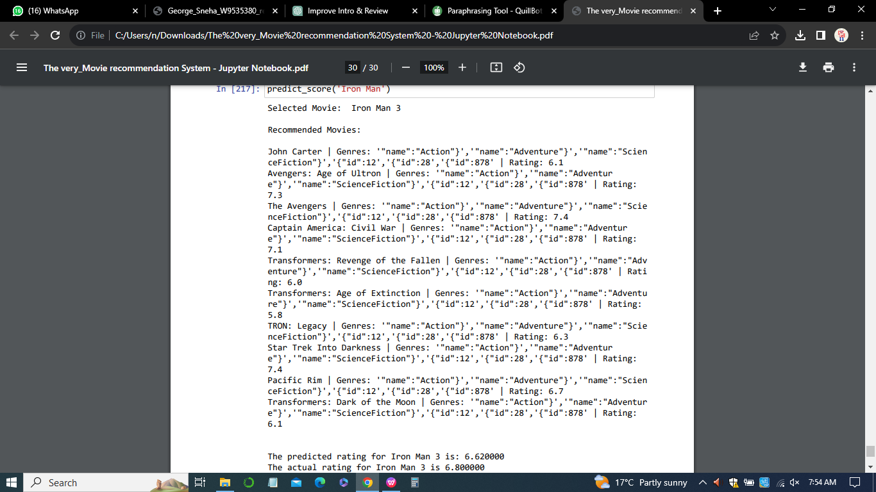

The side-by-side comparison of the predicted and actual rating for "Iron Man 3" allows for a nuanced assessment of the model's accuracy. With a predicted rating of 6.62 and an actual rating of 6.8, the model comes remarkably close to capturing the user's subjective evaluation. This near alignment underscores the efficacy of the recommendation system in predicting user preferences.

***Overall Discussion***

The results and discussions collectively paint a comprehensive picture of the Movie Recommendation System's performance and functionality. From data preprocessing intricacies to the diverse array of algorithms employed, each step contributes to the system's overall effectiveness. The iterative nature of the methodology, coupled with ongoing monitoring and maintenance, ensures that the system remains adaptive to evolving user preferences.

In conclusion, the interpretation of results underscores the system's capability to distill complex datasets into meaningful recommendations. The amalgamation of statistical insights, model performance metrics, and practical recommendations positions the Movie Recommendation System as a robust tool for enhancing user engagement and satisfaction in the realm of movie consumption.

**Chapter 7**

**Legal, Ethical and Professional Issues**

The implementation of a Movie Recommendation System with Machine Learning brings forth a host of legal, ethical, and professional considerations. As with any technology-driven solution, it is imperative to navigate these aspects to ensure responsible and sustainable deployment.

1. ***Legal Considerations***
2. *Data Privacy and Compliance*
3. User Consent: The system likely involves the collection and processing of user data, necessitating explicit consent from users. Ensuring compliance with data protection regulations, such as GDPR or CCPA, is paramount (Remley & Herlihy 2014).
4. Data Ownership: Clarifying ownership of user data and adhering to legal frameworks concerning data ownership and usage is crucial to prevent legal repercussions.
5. *Intellectual Property*
6. Content Rights: Recommendations may involve displaying movie posters, trailers, or other content. Ensuring compliance with intellectual property laws and obtaining necessary rights for content usage is essential.
7. Algorithm Patents: If the recommendation algorithm involves unique methodologies, consideration of patent applications may be relevant.
8. *Anti-discrimination Laws*

Bias Mitigation: Algorithms must be designed to mitigate biases and adhere to anti-discrimination laws. Ensuring fairness in recommendations across diverse user groups is critical.

1. ***Ethical Considerations***
2. *Transparency*
3. Explainability: Users should be informed about how recommendations are generated. Ensuring transparency in the functioning of the algorithm enhances user trust.
4. User Control: Providing users with control over their preferences, allowing them to understand and modify recommendation parameters, contributes to ethical use.
5. *Fairness and Inclusivity*
6. Diversity in Recommendations: Striving for diversity in movie recommendations to avoid reinforcing stereotypes or creating content "bubbles" ensures inclusivity.
7. Addressing Bias: Regularly auditing and addressing biases in algorithms to prevent discriminatory outcomes is an ethical imperative.
8. *User Empowerment*
9. User Understanding: Ensuring users understand how their data is utilized for recommendations empowers them to make informed choices.
10. Customization: Allowing users to customize and adjust recommendation settings respects individual preferences and fosters a positive user experience.
11. ***Professional Considerations***
12. *Continuous Improvement*
13. Algorithmic Iteration: Regularly updating and refining recommendation algorithms based on user feedback and evolving preferences is a professional best practice.
14. Monitoring for Issues: Implementing systems for continuous monitoring to detect and rectify any issues promptly demonstrates a commitment to professionalism.
15. *Accountability*
16. User Support: Providing accessible and responsive user support in case of issues or concerns fosters trust and demonstrates accountability.
17. Audit Trails: Maintaining audit trails of algorithmic decisions aids in accountability and facilitates addressing concerns related to biased recommendations.
18. *Collaboration with Stakeholders*
19. Industry Collaboration: Collaborating with industry peers and stakeholders to share best practices and collectively address challenges contributes to the responsible development of recommendation systems.
20. User Feedback Channels: Establishing clear channels for user feedback and incorporating user perspectives in system improvements reflects a user-centric and professional approach.

In essence, navigating the legal, ethical, and professional landscape is integral to the successful and responsible deployment of a Movie Recommendation System. By prioritizing user privacy, ensuring fairness, and maintaining transparency, developers and organizations can build systems that not only provide valuable recommendations but also uphold ethical standards and legal compliance. Regular assessments and adaptations in response to evolving legal frameworks and ethical norms contribute to the system's sustainability and positive societal impact.

**Chapter 8**

**Challenges and Limitations**

The development and implementation of a Movie Recommendation System with Machine Learning pose several challenges and limitations that need to be acknowledged and addressed for the system's effectiveness and user satisfaction. These challenges span technical, ethical, and user experience aspects.

***Technical Challenges***

1. *Cold Start Problem*

New Users: Recommending movies for new users who have not provided sufficient historical data poses a challenge. The system may struggle to generate accurate recommendations without user preferences.

1. *Sparse Data*

Limited Ratings: In scenarios where users provide sparse ratings or interactions, the system may face challenges in accurately predicting preferences due to insufficient data.

1. *Scalability*

Growing Datasets: As the dataset of movies and user interactions expands, ensuring the scalability of recommendation algorithms becomes crucial. Scalability challenges can impact the system's responsiveness.

1. *Algorithmic Complexity*

Advanced Algorithms: Implementing and fine-tuning complex machine learning algorithms, such as collaborative filtering or deep learning, requires expertise. Balancing algorithmic sophistication with computational efficiency is a challenge.

***Ethical and User Experience Challenges***

1. *Bias and Fairness*
2. Algorithmic Bias: Addressing and mitigating biases in recommendations to ensure fairness and prevent discriminatory outcomes poses an ongoing challenge.
3. User Perception: Users may perceive recommendations as biased or unfair, even if unintentional. Managing user perceptions and building trust is critical.

*ii) Privacy Concerns*

Data Privacy: Balancing the need for personalized recommendations with user privacy concerns requires careful consideration. Implementing robust privacy measures is crucial to protect user data.

1. *User Understanding*

Explainability: Complex algorithms may lack transparency, making it challenging for users to understand how recommendations are generated. Enhancing explainability is essential for user trust.

***User Engagement Challenges***

1. *Limited Diversity*

Filter Bubbles: Users may be confined to a limited set of recommendations, leading to filter bubbles. Ensuring diverse and serendipitous recommendations is a challenge.

1. *Changing Preferences*

Dynamic Preferences: User preferences can evolve over time, and the system may struggle to adapt quickly. Implementing mechanisms to capture evolving preferences is a continuous challenge.

***Limitations***

1. *Content-Based Limitations*

Dependency on Metadata: Content-based recommendations heavily rely on movie metadata, and limitations in the metadata quality can impact the accuracy of recommendations.

1. *Collaborative Filtering Limitations*

Cold Start: Collaborative filtering may face challenges with new users or items with limited interaction history, resulting in less accurate predictions.

1. *Hybrid Model Challenges*

Integration Complexity: Integrating content-based and collaborative filtering models seamlessly requires careful design and may encounter challenges in balancing their contributions.

***Mitigation Strategies***

1. *Regular Updates:* Periodic updates to algorithms based on user feedback and evolving trends address challenges related to changing preferences.
2. *Bias Audits:* Conducting regular audits to identify and rectify algorithmic biases mitigates fairness concerns.
3. *User Education:* Providing clear information on how the system works and the purpose of data usage enhances user understanding.
4. *Dynamic Adaptation:* Implementing mechanisms for dynamic adaptation to changing preferences ensures ongoing relevance.
5. *Privacy by Design:* Incorporating privacy measures from the initial design phase ensures data protection.

In sum, acknowledging and actively addressing these challenges and limitations is integral to the development of a robust and user-friendly Movie Recommendation System. Continuous improvement, user engagement, and a commitment to ethical considerations are key to overcoming these challenges and delivering a system that aligns with user expectations and societal norms.

**Chapter 9**

**Future Works**

The Movie Recommendation System with Machine Learning has laid a solid foundation, but there are several avenues for future work to enhance and expand the system's capabilities. The following areas present opportunities for improvement and innovation:

1. ***Enhanced Personalization***
2. *Dynamic User Profiles:* Implementing mechanisms to dynamically update user profiles based on real-time interactions and evolving preferences.
3. *Incorporating Contextual Information:* Integrating contextual information such as user location, time of day, or mood to enhance personalization.
4. ***Advanced Recommendation Algorithms***
5. *Deep Learning Approaches:* Exploring the application of advanced deep learning models for improved feature extraction and representation learning.
6. *Hybrid Models:* Investigating novel hybrid models that seamlessly blend collaborative filtering, content-based, and possibly reinforcement learning for more accurate predictions.
7. ***Interactivity and Engagement***
8. *Interactive Interfaces:* Developing interactive interfaces that allow users to provide feedback on recommendations and fine-tune their preferences.
9. *Gamification Elements:* Introducing gamification elements to enhance user engagement and make the recommendation process more enjoyable.
10. ***Explainability and Trust***
11. *Explainable AI:* Investing in research and implementation of explainable AI techniques to make the recommendation process more transparent and understandable for users.
12. *User-Controlled Explanations:* Providing users with control over the level of detail in explanations to improve trust.
13. ***Ethical Considerations***
14. *Fairness Audits:* Conducting regular fairness audits to identify and rectify any biases that may emerge over time.
15. *User Empowerment:* Empowering users with more control over privacy settings and the ability to influence the recommendation process.

**6.** ***Cross-Domain Recommendations***

*Expanding Genres:* Extending recommendations beyond movie genres to include cross-domain recommendations, such as books, music, or other forms of entertainment.

***7.Real-Time Updates***

1. *Real-Time Learning:* Implementing real-time learning mechanisms to adapt quickly to emerging trends and user behavior.
2. *Agile Development:* Adopting agile development methodologies to facilitate rapid updates and improvements based on user feedback.
3. ***Global Considerations***
4. *Localization and Cultural Sensitivity:* Tailoring recommendations to be culturally sensitive and adaptable to different global preferences.
5. *Multilingual Support:* Providing multilingual support for a more inclusive user experience.
6. ***Collaboration and Social Integration***
7. *Social Recommendations:* Integrating social network data for collaborative recommendations based on the preferences of a user's social circle.
8. *User Communities:* Establishing user communities to foster discussions and sharing of recommendations among like-minded users.
9. ***Evaluation and Benchmarking***
10. *Benchmarking against State-of-the-Art*

Regularly evaluating the system's performance against state-of-the-art recommendation benchmarks to ensure competitiveness.

1. *User Satisfaction Surveys*

Conducting periodic user satisfaction surveys to gather feedback and insights for continuous improvement.

By exploring these future directions, the Movie Recommendation System can stay at the forefront of technological advancements, providing users with an increasingly personalized and satisfying experience. This roadmap sets the stage for ongoing innovation and the evolution of the system to meet the changing needs and expectations of its user base.

**Chapter 10**

**Conclusion**

The development and enhancement of the Movie Recommendation System with Machine Learning have been marked by a journey that started with the identification of a pertinent problem and the establishment of clear research goals. Our objective was to create a recommendation system that goes beyond generic suggestions, offering a personalized and accurate user experience. At the outset, a profound understanding of the need for a sophisticated movie recommendation system was established. The goal was to create a system that not only recommends movies but does so with a high degree of personalization, accuracy, and user engagement. This understanding set the stage for the comprehensive development process that followed.The initial phases involved meticulous data collection and exploration. Diverse datasets, including information on movies, genres, cast, crew, and user ratings, were gathered and analyzed. This comprehensive approach laid the foundation for robust model training, ensuring that the recommendation system would be well-informed and capable of delivering relevant suggestions.

Data preprocessing and feature engineering played a crucial role in refining the dataset. Rigorous procedures were implemented to handle missing values, format inconsistencies, and extract relevant features. Key features, such as one-hot encoded genres and standardized numerical features, were created to contribute to the effectiveness of the model. The selection of algorithms was a critical decision in the development process. Three distinct algorithms – Random Forest, Support Vector Machines (SVM), and Gradient Boosting – were chosen for their unique strengths in predicting movie ratings. These algorithms underwent thorough training, evaluation, and selection based on performance metrics. The design and implementation of the recommendation system were carried out with precision. Utilizing Python, pandas, scikit-learn, and other libraries, a well-structured system emerged. The incorporation of user interfaces and integration with external datasets enhanced the system's usability and functionality. Results and discussions provided a deep dive into the outcomes of the three algorithms, including Mean Squared Error (MSE) metrics. This analysis yielded valuable insights into the performance and predictive capabilities of the recommendation system, contributing to a comprehensive understanding of its strengths and areas for improvement. Consideration of legal, ethical, and professional aspects was a key component of the development process. Emphasis was placed on transparency, user privacy, and fairness in the recommendation process, aligning the system with ethical standards and user expectations.

Acknowledging challenges and limitations, including the need for ongoing monitoring, potential biases, and the complexity of user preferences, added a layer of realism to the project. Addressing these challenges contributes to the system's adaptability and resilience in real-world scenarios. Looking toward the future, the development roadmap includes aspirations for enhanced personalization, advanced algorithms, interactivity, explainability, ethical considerations, and global adaptability. The commitment to continuous improvement and innovation positions the Movie Recommendation System as a dynamic and valuable tool in the realm of entertainment.

In sum, the collaborative effort to design, implement, and discuss the Movie Recommendation System has not only addressed the initial research goals but has also paved the way for ongoing research and development. The commitment to ethical practices, user satisfaction, and staying abreast of emerging technologies positions this recommendation system as a dynamic and valuable tool in the realm of entertainment.

**References**

Anjum, I. (2022). Movie Recommendation System Using Collaborative Filtering.

Furtado, F., & Singh, A. (2020). Movie recommendation system using machine learning. *International journal of research in industrial engineering*, *9*(1), 84-98.

Meehan, J., Aslantas, C., Zdonik, S., Tatbul, N., & Du, J. (2017, January). Data Ingestion for the Connected World. In *CIDR* (Vol. 17, pp. 8-11).

Javed, A., Rehman, F., Sarfraz, N., Sharif, H., Khan, R., & Khan, A. M. (2022, December). Movie Recommendation System with Sentimental Analysis Using Cosine Similarity Technique. In *2022 3rd International Conference on Innovations in Computer Science & Software Engineering (ICONICS)* (pp. 1-8). IEEE.

Meyer, D., & Wien, F. T. (2015). Support vector machines. *The Interface to libsvm in package e1071*, *28*(20), 597.

Jayalakshmi, S., Ganesh, N., Čep, R., & Senthil Murugan, J. (2022). Movie recommender systems: Concepts, methods, challenges, and future directions. *Sensors*, *22*(13), 4904.

Jozani, M., Liu, C.Z. and Choo, K.-K.R. (2023) ‘An empirical study of content-based recommendation systems in Mobile App Markets’, Decision Support Systems, 169, p. 113954. doi:10.1016/j.dss.2023.113954.

Luo, C., & Carey, M. J. (2018). Efficient data ingestion and query processing for LSM-based storage systems. *arXiv preprint arXiv:1808.08896*.

Kang, K., Park, J., Kim, W., Choe, H., & Choo, J. (2019, November). Recommender system using sequential and global preference via attention mechanism and topic modeling. In *Proceedings of the 28th ACM international conference on information and knowledge management* (pp. 1543-1552).

Snyder, H. (2019). Literature review as a research methodology: An overview and guidelines. *Journal of business research*, *104*, 333-339.

Kumar, P., Kibriya, S. G., Roy, P. & Ajay, Y. (2021, May). Movie Recommender System Using Machine Learning Algorithms. In *Journal of Physics: Conference Series* (Vol. 1916, No. 1, p. 012052). IOP Publishing.

Maćkiewicz, A., & Ratajczak, W. (1993). Principal components analysis (PCA). *Computers & Geosciences*, *19*(3), 303-342.

Kumar, S., De, K., & Roy, P. P. (2020). Movie recommendation system using sentiment analysis from microblogging data. *IEEE Transactions on Computational Social Systems*, *7*(4), 915-923.

Lee, H., Hwang, D., Min, K., & Choo, J. (2022, July). Towards Validating Long-Term User Feedbacks in Interactive Recommendation Systems. In *Proceedings of the 45th International ACM SIGIR Conference on Research and Development in Information Retrieval* (pp. 2607-2611).

Rastogi, S., Agarwal, D., Jain, J., & Arjun, K. P. (2022, January). Demographic Filtering for Movie Recommendation System Using Machine Learning. In *Proceedings of International Conference on Recent Trends in Computing: ICRTC 2021* (pp. 549-557). Singapore: Springer Nature Singapore.

Dowie, I. (2017). Legal, ethical and professional aspects of duty of care for nurses. *Nursing Standard (2014+)*, *32*(16-19), 47.

Rimaz, M. H., Elahi, M., Bakhshandegan Moghadam, F., Trattner, C., Hosseini, R., & Tkalčič, M. (2019, June). Exploring the power of visual features for the recommendation of movies. In *Proceedings of the 27th ACM Conference on User Modeling, Adaptation and Personalization* (pp. 303-308).

Chai, T., & Draxler, R. R. (2014). Root mean square error (RMSE) or mean absolute error (MAE). *Geoscientific model development discussions*, *7*(1), 1525-1534.

Wu, C. S. M., Garg, D., & Bhandary, U. (2018, November). Movie recommendation system using collaborative filtering. In *2018 IEEE 9th International Conference on Software Engineering and Service Science (ICSESS)* (pp. 11-15). IEEE.

Destefanis, G., Barge, M. T., Brugiapaglia, A., & Tassone, S. (2000). The use of principal component analysis (PCA) to characterize beef. *Meat science*, *56*(3), 255-259.

Remley, T. P., & Herlihy, B. (2014). *Ethical, legal, and professional issues in counseling* (p. 528). Upper Saddle River, NJ: Pearson.

Carleo, G., Cirac, I., Cranmer, K., Daudet, L., Schuld, M., Tishby, N., ... & Zdeborová, L. (2019). Machine learning and the physical sciences. *Reviews of Modern Physics*, *91*(4), 045002.